Abstract.

Table of Contents.

List of Figures.
Fig1. The graphs of the amplitude and phase response
Fig2. The frequency when amplitude is -3dB
Fig3. The magnitude and phase of output voltage
Fig4. The input-output pairs
Fig5. The comparison of input and output spectra
Fig6. The output spectra
Fig7. The input and output time domain waveforms

1.INTRODUCTION.

2. Method.
numbers that were measured were later changed into volts. Then checked against the theoretical value (Edith Cowan University, n.d.).
- Results.
3.1 Verify frequency response in time domain
Vout=15*H(jω)
amplitude ratio can be calculated by:
$$|H(jω)|=\frac{1}{\sqrt{1+{(ωRC)}^{2}}}$$

so if f=1kHz, $ωRC=2π∗1000∗1.5∗{10}^{−5}=0.09425$
$$|H(jω)|=\frac{1}{\sqrt{1+{0.09425}^{2}}}≈0.9956$$
Vtheo=15*0.9956=14.93,$∠$Vo=0+$∠$H(jω)=-5.39$°$
so if f=10kHz, $ωRC=2π∗10000∗1.5∗{10}^{−5}=0.9425$
$|H(jω)|=\frac{1}{\sqrt{1+{0.9425}^{2}}}≈0.727$7
Vtheo=15*0.7277=10.92,$∠$Vo=0+$∠$H(jω)=-43.3$°$
so if f=40kHz, $ωRC=2π∗40000∗1.5∗{10}^{−5}=3.7699$
$$|H(jω)|=\frac{1}{\sqrt{1+{3.7699}^{2}}}≈0.2568$$
Vtheo=15*0.2568=3.86,$∠$Vo=0+$∠$H(jω)=--75.1$°$
Frequency | Magnitude |  | Phase
Frequency | Theoretical Value | Measured Value | Theoretical Value | Measured Value
1kHz | 14.93 | 15.4 | -5.39$°$ | -6.98$°$
10kHz | 10.92 | 11.4 | -43.3$°$ | -42.86$°$
40kHz | 3.86 | 4.08 | -75.1$°$ | -67.48$°$
Table5. Theoretical frequency response vs measured frequency response
- Sketch of input-output pairs
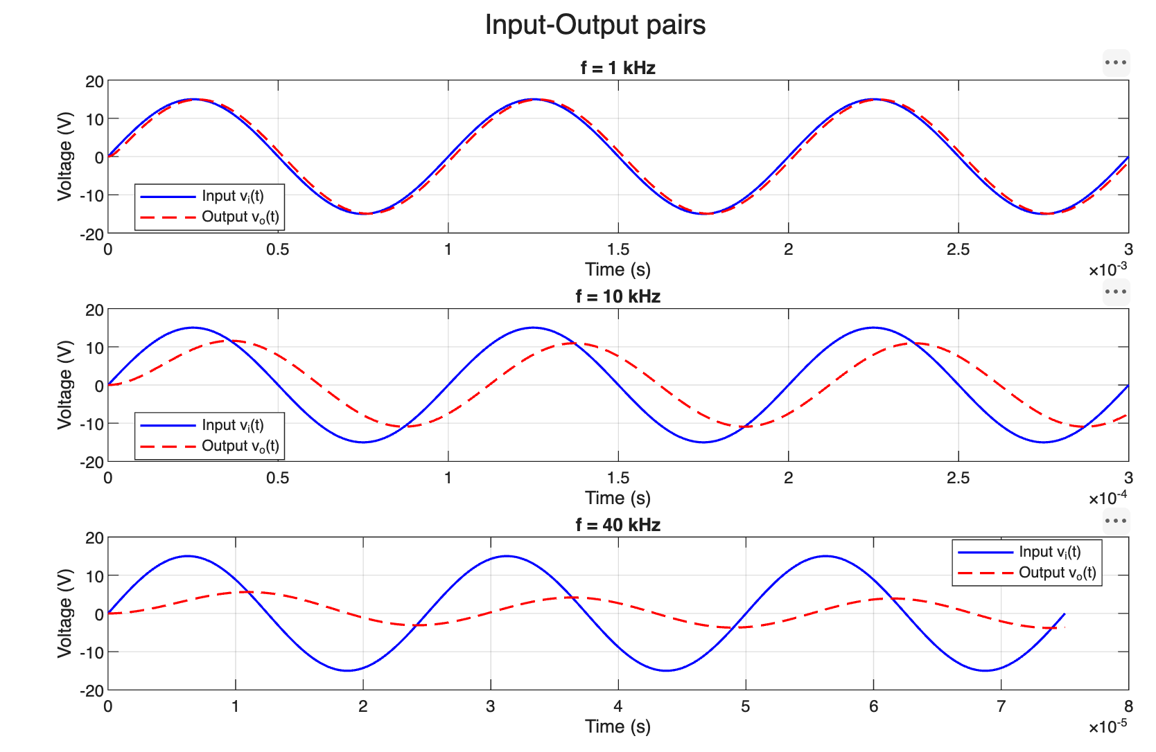
Fig4. The input-output pairs
- Filtering type and comparison of cut-off frequency(-3dB point) between the measured and theoretical values.
This RC circuit is a kind of low pass filter, which allows low frequency signals to pass through it with little diminish, but as for the high frequency signals, they are diminished sharply.
The frequency of the circuit can be calculated by using the formula below:
$$f=\frac{1}{2πRC}≈10.61kHz$$
3.2 Verify frequency response in frequency domain
dB cam be calculated by:
$$dB=20lg|H(jω)|$$
so if f=1kHz: 20lg(0.9956)$≈$-0.038dB
if f=10kHz: 20lg(0.7277)$≈$-2.761dB
if f=40kHz: 20lg(0.2568)$≈$-11.822dB
the valid value can be calculated by:
$$V_{valid}=\frac{V_{peak}}{\sqrt{2}}$$
the measured gain=Vout-Vin
so, if f=1lkHz, from the figxxxxxxxxxx. the Vin=15.6V, Vout=15.4V,
$V_{valid(in)}=\frac{15.6}{\sqrt{2}}≈11.0309V$, dBV(input)=20lg(11.0309)=20.85dBV
$V_{valid(out)}=\frac{15.4}{\sqrt{2}}≈10.8894V$, dBV(output)=20lg(10.8894)=20.74dBV
the measured gain=20.74-20.85=-0.11dB
so, if f=10lkHz, from the figxxxxxxxxxx. the Vin=15.6V, Vout=11.4V,
$V_{valid(in)}=\frac{15.6}{\sqrt{2}}≈11.0309V$, dBV(input)=20lg(11.0309)=20.85dBV
$V_{valid(out)}=\frac{11.4}{\sqrt{2}}≈8.061V$, dBV(output)=20lg(8.061)=18.13dBV
the measured gain=18.13-20.85=-2.72dB
so, if f=40lkHz, from the figxxxxxxxxxx. the Vin=15.4V, Vout=4.08V,
$V_{valid(in)}=\frac{15.4}{\sqrt{2}}≈10.8894V$, dBV(input)=20lg(10.8894)=20.74dBV
$V_{valid(out)}=\frac{4.08}{\sqrt{2}}≈2.885V$, dBV(output)=20lg(2.885)=9.20dBV
the measured gain=9.20-20.74=-11.54dB
Frequency | Output Magnitude | Input Magnitude | Magnitude Gain | Theoretical Response
1kHz | 20.74dBV | 20.85dBV | -0.11dB | -0.038dB
10kHz | 18.13dBV | 20.85dBV | -2.72dB | -2.761dB
40kHz | 9.20dBV | 20.74dBV | -11.54dB | -11.822dB
Table6. Frequency response (magnitude) for sinusoids
- Comparison of measured results with theoretical (post-lab) values
The values between measured results and theoretical values were fit well. But for the f=1kHz, the value differs several times, this may cause by vibe noise, poor contact and so on.
- Sketches of output spectra and description of comparison
The graph shows below:
From the graph, at 1kHz, the input and output magnitude are almost analogous. At 10kHz, the output magnitude differs slighter than the condition of 1kHz. But at 40kHz, the output magnitude slumps. There are the characteristics of low pass filter, which allows low frequency signals to pass through it with little diminish, but as for the high frequency signals, they are diminished sharply.
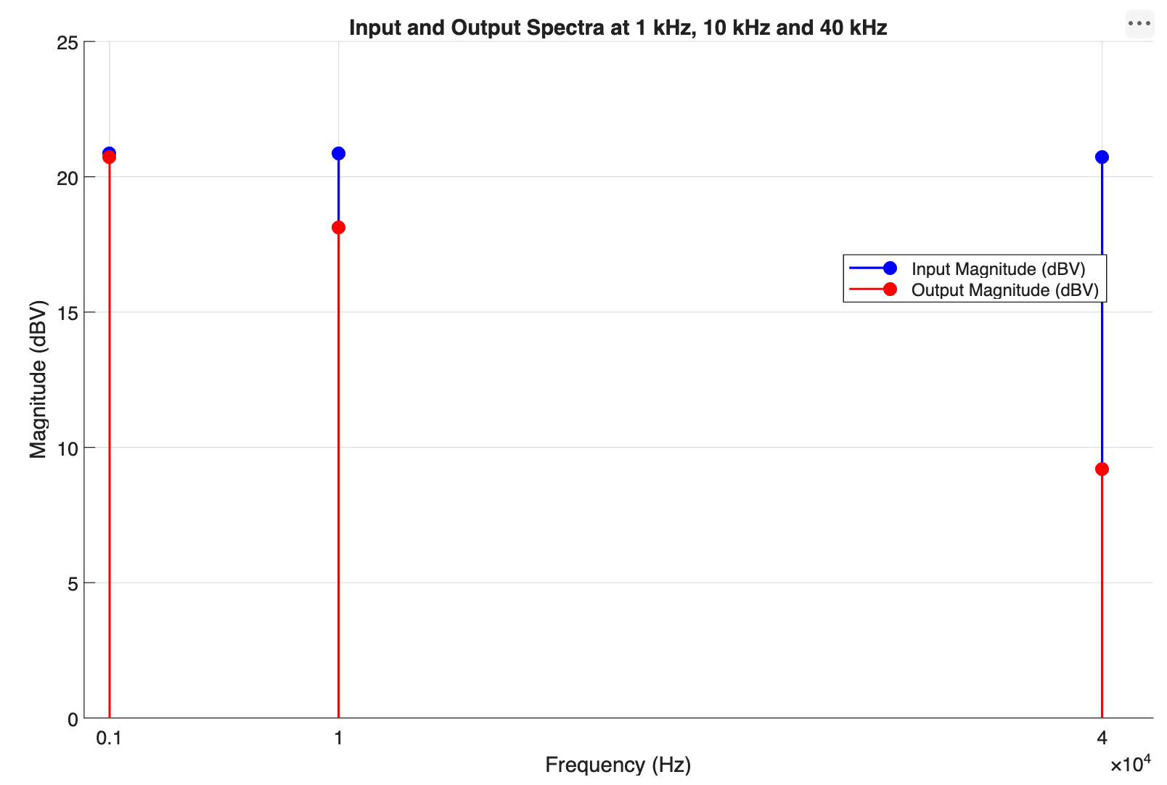
Fig5. The comparison of input and output spectra
3.3 Response to square wave input
1) The calculation of the input magnitude shows in 4.3 b) and c)
Spectrum characteristic | Output Magnitude | Input Magnitude | Magnitude Response | Theoretical Response
Fundamental | 16.4063dBV | 22.61dBV | -6.20dB | -1.96dB
3rd harmonic | 6.71875dBV | 13.06dBV | -6.34dB | -7.91dB
5th harmonic | 2.5dBV | 8.63dBV | -6.13dB | -11.85dB
Table7. Square wave theoretical vs measured harmonic response
- Sketch of output spectra
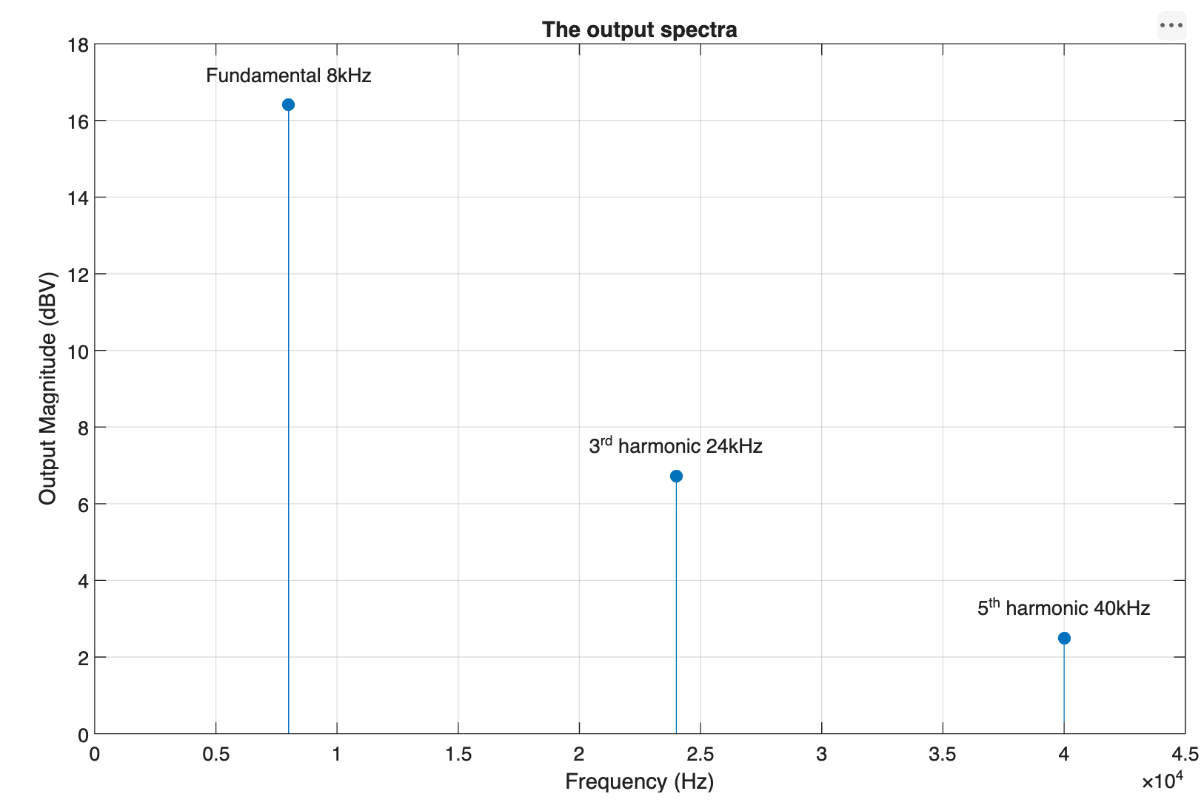
Fig6. The output spectra
- Sketch of input and output time domain waveforms and explanation
$$T=\frac{1}{f}=\frac{1}{8000}=125μs$$
For the input waveform:
$$V_{in}(t)=\sum_{n=odd}{\frac{4V}{nπ}sin(nω_{0}t)}$$
n=1,$V_{in}(t)=19.1$V
n=3,$V_{in}(t)=$6.37V
n=5,$V_{in}(t)=$3.82V
so$,V_{in}(t)=19.1sinsin(nω_{0}t)+6.37sinsin(3ω_{0}t)+3.82sinsin(5ω_{0}t)$
For the output waveform:
$$V=\sqrt{2}∗{10}^{\frac{dBV}{20}}$$
f=8kHz, Vout1=9.27V
f=24kHz, Vout2=3.07V
f=40kHz, Vout3=1.89V
$$∠H(jω)=∠(1)−∠(1+jωRC)$$
$$=arctan0−arctan\frac{ωRC}{1}$$
$$=−arctan(ωRC)=θ$$
for f = 8KHz $ω$RC=2πfRC=0.754,$∠H(jω)$=$−arctan(0.754)≈−37.02°$
for f = 24KHz $ω$RC=2πfRC=2.2619,$∠H(jω)$=$−arctan(2.2619)−66.15°$
for f = 40KHz $ω$RC=2πfRC=3.7699,$∠H(jω)$=$−arctan(3.7699)≈−75.14°$
so,$V_{out}(t)=9.27∗sin(ω_{0}t−37.02°)+6.37∗sin(ω_{0}t−66.15°)+3.82∗sin(ω_{0}t−75.14°)$
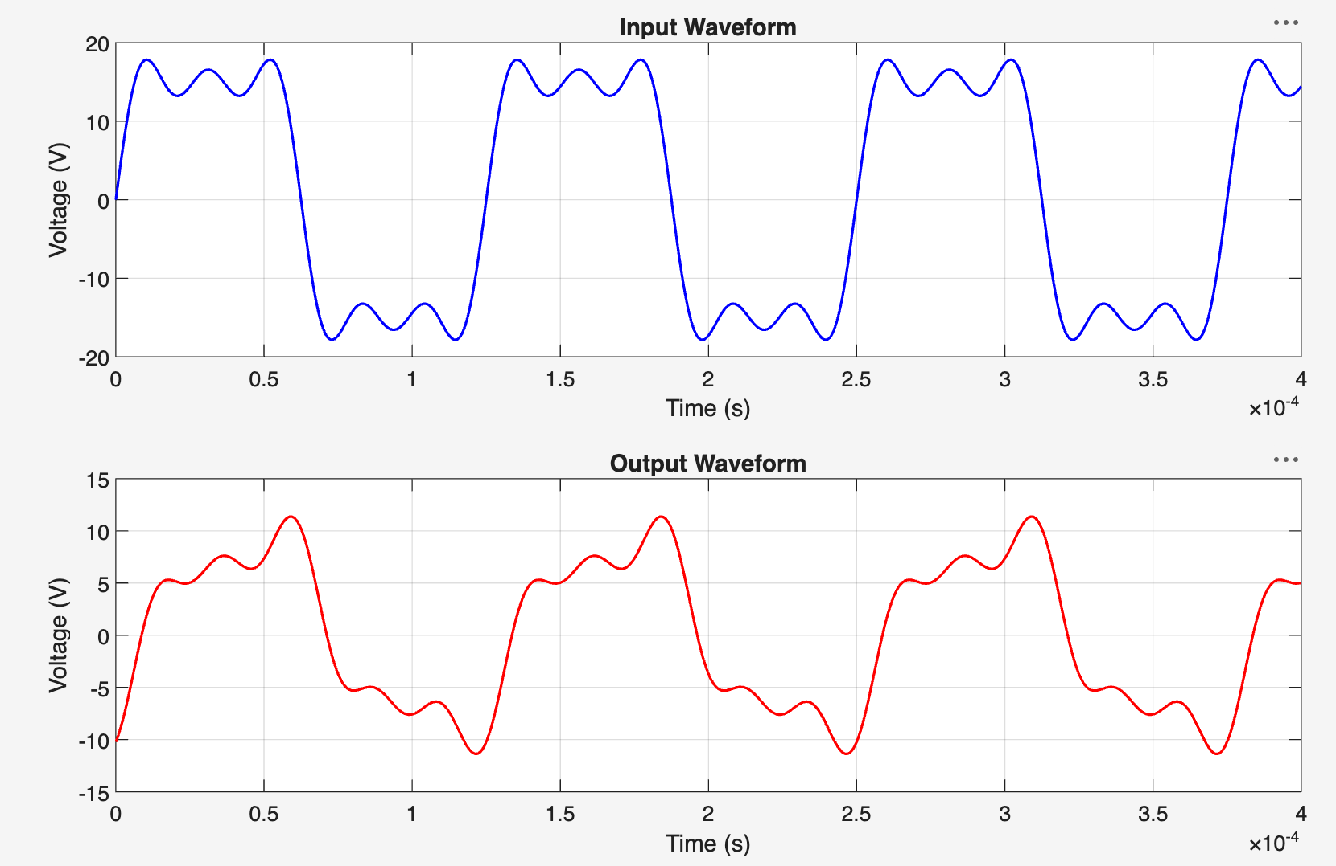
Fig7. The input and output time domain waveforms
explanation:
The first graph is input waveform and it’s similar to the square signal. The second graph is output waveform.
There are some differences between the matlab graph and real oscilloscope for the probable reasons of vibe noise, poor contact and so on.

Discussion.
4.1 Frequency response of an RC circuit
- Determining the frequency response, H(jω)
$$RC\frac{dv_{o}(t)}{dt}+v_{o}(t)=v_{i}(t)$$
using Fourier transform on both sides:
$$RCjωV_{o}(ω)+V_{o}(ω)=V_{i}(ω)$$
$$V_{o}(ω)(RCjω+1)=V_{i}(ω)$$
$$H(jω)=\frac{V_{o}(ω)}{V_{i}(ω)}=\frac{1}{1+jωRC}$$
- Calculating|H(jω)|
According to the formulas:
ω=2πf
$$dB=20lg|H(jω)|$$
$$|H(jω)|=\frac{1}{\sqrt{1+{(ωRC)}^{2}}}$$
$$∠H(jω)=∠(1)−∠(1+jωRC)=arctan0−arctan\frac{ωRC}{1}=−arctan(ωRC)$$
for f = 1KHz $ω$=2πf=6238.19rad/s,$∠H(jω)$=$−arctan(0.09425)≈−5.39°$
for f = 10KHz $ω$=2πf=62381.85rad/s,$∠H(jω)$=$−arctan(0.9425)−43.3°$
for f = 40KHz $ω$=2πf=251327.41rad/s,$∠H(jω)$=$−arctan(3.77)≈−75.1°$
f | ω(rad/s) | |H(jω)| | |H(jω)| in dB
1kHz | 6283.19 | 0.9956 | -0.038
10kHz | 62831.85 | 0.7277 | -2.761
40kHz | 251327.41 | 0.2568 | -11.822
Table1. The calculation of H(jω)|
- Plot of amplitude and phase response
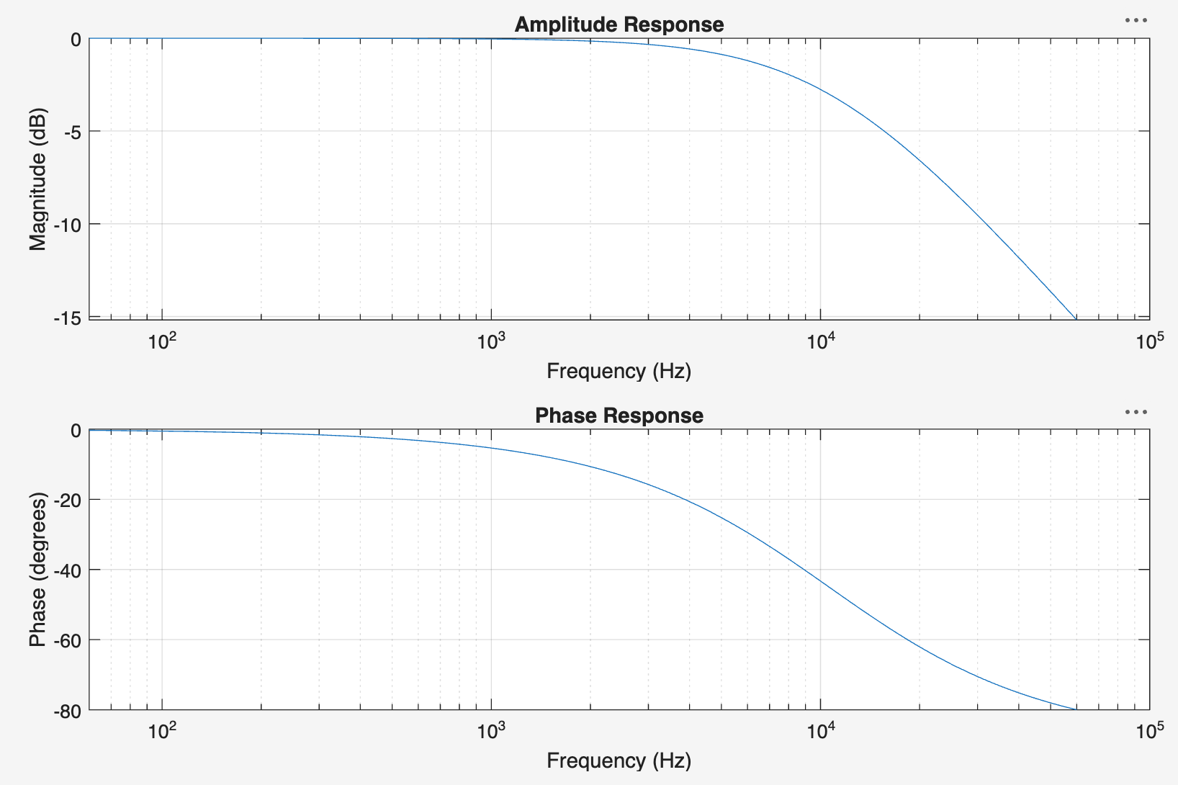
Fig1. The graphs of the amplitude and phase response
- Questions
- What kind of filtering is performed by this RC circuit?
This RC circuit is a kind of low pass filter, which allows low frequency signals to pass through it with little diminish, but as for the high frequency signals, they are diminished sharply.
- What does -3db equate to in terms of voltage amplitude ratio?
According to the formula:
$$dB=20lg|H(jω)|$$
when the value is -3db,$20lg|H(jω)|=−3$, so the amplitude:$|H(jω)|={10}^{−\frac{3}{20}}≈0.708$
- What is the cut-off frequency(-3db point on the plot)?
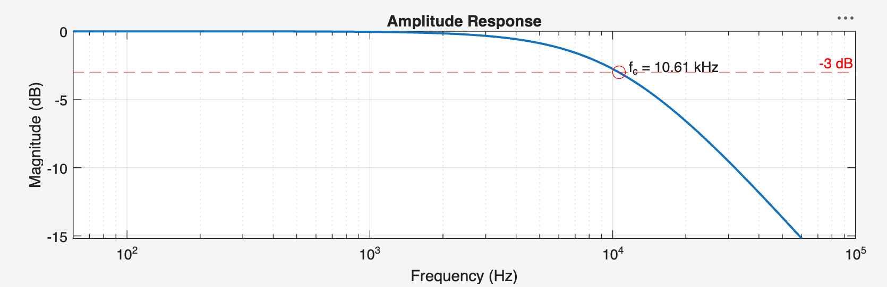
Fig2. The frequency when amplitude is -3dB
According to the graph above, the cut-off frequency when db is -3 is 10.61kHz
- How can we determine this value from the circuit parameters?
The frequency of the circuit can be calculated by using the formula below:
$$f=\frac{1}{2πRC}≈10.61kHz$$
- Describe the behavior of this system in the frequency domain and in the time domain.
Frequency domain:
The system is a low pass filter system, so low frequency signals pass through it with little diminishment while the high frequency signals pass through it with sharp diminishment.
Time domain:
Low frequency signals pass through it with little change but the signals diminish when the frequency increases.
4.2 Response of the RC circuit to an AC voltage using the frequency response
- Theoretical output voltage
the phase shift is 0.
Vout=15*H(jω):
so if f=1kHz, |Vo|=15*0.9956=14.93,$∠$Vo=0+$∠$H(jω)=-5.39$°$,
so if f=10kHz, |Vo|=15*0.7277=10.92,$∠$Vo=0+$∠$H(jω)=-43.3$°$
so if f=40kHz, |Vo|=15*0.2568=3.86,$∠$Vo=0+$∠$H(jω)=--75.1$°$

f | ω(rad/s) | |H(jω)| | $∠$H(jω) | |Vo| | $∠$Vo
1kHz | 6283.19 | 0.9956 | -5.39$°$ | 14.93 | -5.39$°$
10kHz | 62831.85 | 0.7277 | -43.3$°$ | 10.92 | -43.3$°$
40kHz | 251327.41 | 0.2568 | -75.1$°$ | 3.86 | -75.1$°$
Table2. Theoretical output voltage
- Magnitude and phase spectra of output voltage
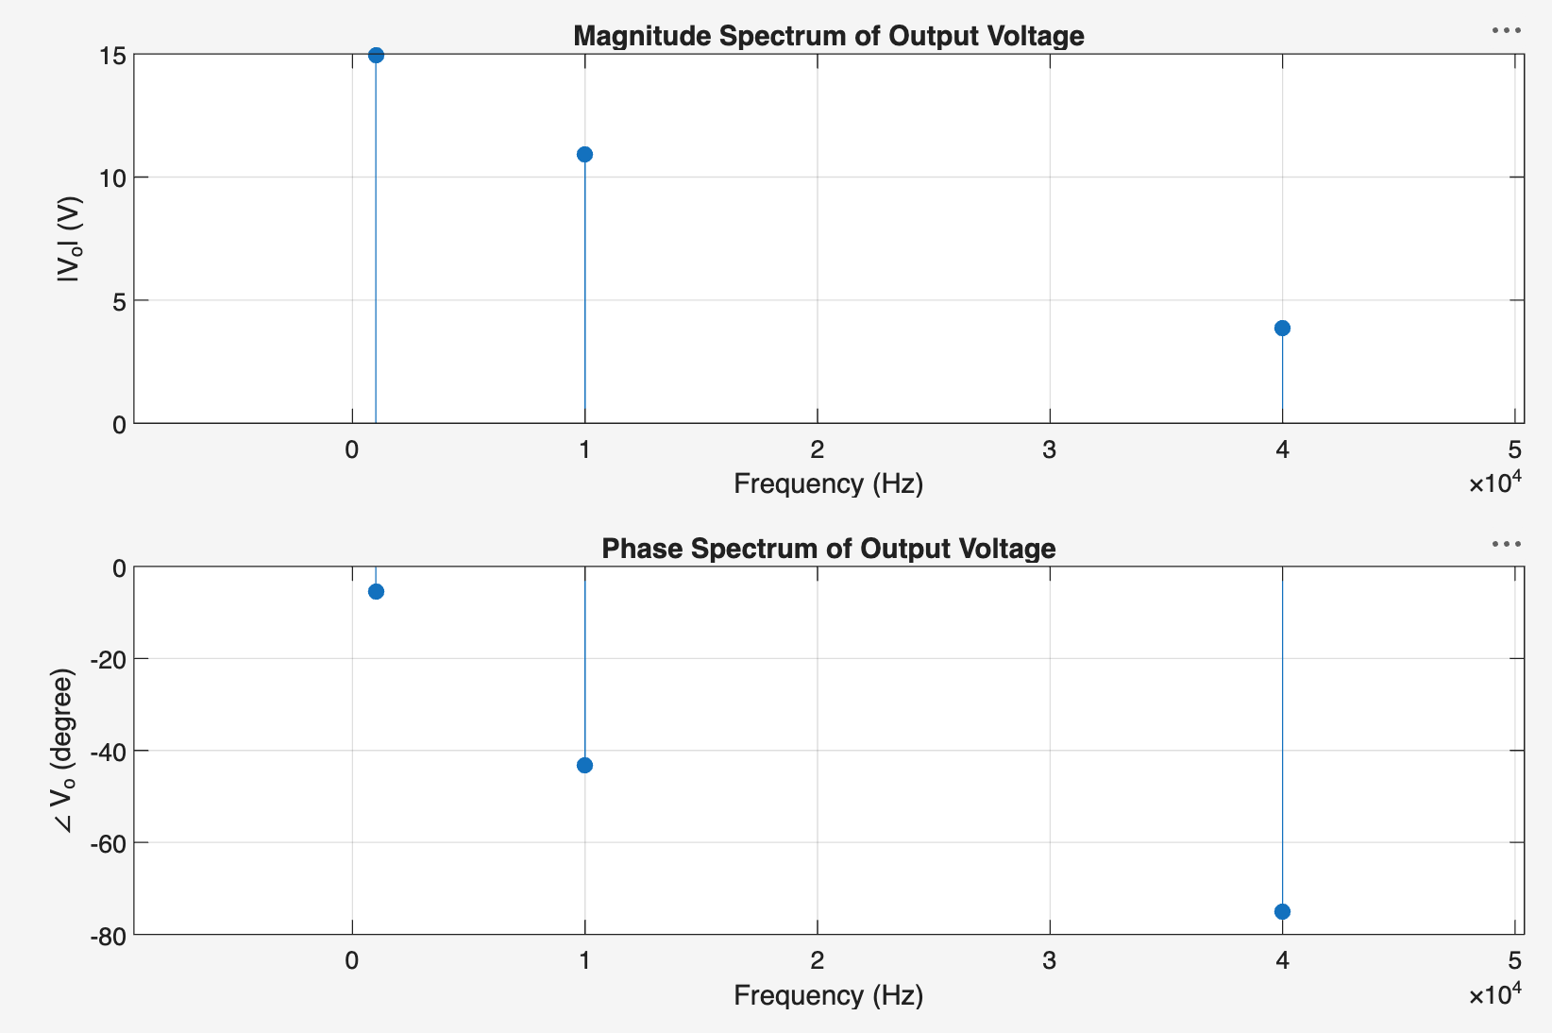
Fig3. The magnitude and phase of output voltage
4.3 Response of the RC circuit to square wave using the frequency response
- Fourier Series coefficients
$V_{p}=$15V
$f_{0}=8k$Hz
$$x(t)=\left\{\begin{aligned}V, 0<t<\frac{T_{0}}{2} \\ −V, \frac{T_{0}}{2}<t<T_{0}\end{aligned}\right.$$
$$a_{0}=\frac{1}{T_{0}}\int_{0}^{T_{0}}{x(t)dt}=0$$
$$a_{n}=\frac{2}{T_{0}}\int_{0}^{T_{0}}{x(t)cos(nω_{0}t)dt}=0$$
$$b_{n}=\frac{2}{T_{0}}\int_{0}^{T_{0}}{x(t)sin(nω_{0}t)dt}=\frac{4V}{nπ}(n=1,3,5,7...)$$
if n is even, bn=0
so if n=1 $b_{1}=\frac{4V}{nπ}=\frac{4∗15}{1∗π}≈19.10V$
if n=3, $b_{3}=\frac{4V}{nπ}=\frac{4∗15}{3∗π}≈6.37V$
if n=5, $b_{5}=\frac{4V}{nπ}=\frac{4∗15}{5∗π}≈3.82V$
Fourier Coefficient(b_{n}) | Value | Frequency
b1 | 19.10V | 8kHz
b3 | 6.37V | 24kHz
b5 | 3.82V | 40kHz
Table3. Theoretical output voltage
- and c) Magnitude of frequency response and Magnitude of harmonics
ω₁=2π*8000=50265.48rad/s
|H1|=$\frac{1}{\sqrt{1+{(ωRC)}^{2}}}=\frac{1}{\sqrt{1+{(50265.48∗1.5∗{10}^{−5})}^{2}}}≈0.798$
ω₃=2π*24000=150796.45rad/s
|H3|=$\frac{1}{\sqrt{1+{(ωRC)}^{2}}}=\frac{1}{\sqrt{1+{(150796.45∗1.5∗{10}^{−5})}^{2}}}≈0.402$
ω₅=2π*40000=251327.41rad/s
|H5|=$\frac{1}{\sqrt{1+{(ωRC)}^{2}}}=\frac{1}{\sqrt{1+{(50265.48∗1.5∗{10}^{−5})}^{2}}}≈0.257$
V1out=19.1*0.798$≈$15.24V, V1invalid=19.1/$\sqrt{2}≈$13.51V, dBV=20lg(13.51)$≈$22.61dBV,
V1outvalid=15.24/$\sqrt{2}≈$10.78V, dBV=20lg(10.78)$≈$20.65dBV
V3=6.37*0.402$≈$2.56V, V3invalid=6.37/$\sqrt{2}≈$4.50V, dBV=20lg(4.50)$≈$13.06dBV,
V3outvalid=2.56/$\sqrt{2}≈$1.81V, dBV=20lg(1.81)$≈$5.15dBV
V5=3.82*0.257$≈$0.982V, V5invalid=3.82/$\sqrt{2}≈$2.70V, dBV=20lg(4.50)$≈$8.63dBV,
V3outvalid=0.982/$\sqrt{2}≈$0.69V, dBV=20lg(0.69)$≈$-3.22dBV
f(Hz) | ω(rad/s) | |H(jω)| | Input magnitude(b_{n}) |  | Output magnitude
f(Hz) | ω(rad/s) | |H(jω)| | V | dBV | V | dBV
Fundamental=8kHz | 50265.48 | 0.798 | 19.10 | 22.61 | 15.24 | 20.65
3rd harmonic=24kHz | 150796.45 | 0.402 | 6.37 | 13.06 | 2.56 | 5.15
5th harmonic=40kHz | 251327.41 | 0.257 | 3.82 | 8.63 | 0.982 | -3.22
Table4. Magnitude of frequency response and Magnitude of harmonics

- Description of output waveform
This low pass filter will diminish high frequency signals. According to the values, the fundamental component passes through with little deminishment while the 3rd and 5th signals are diminished heavily.

5. Conclusion.

6.REFERENCES.

7.Group Work Declaration.

8.Appendix
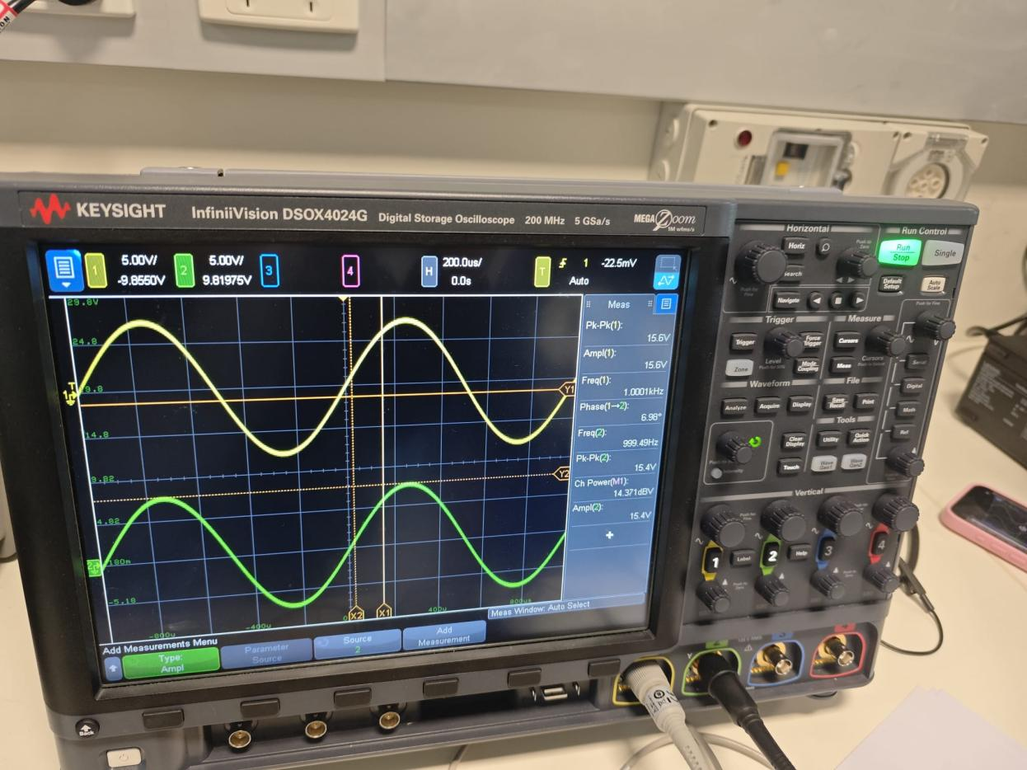
Fig8. Measured value for f=1kHz
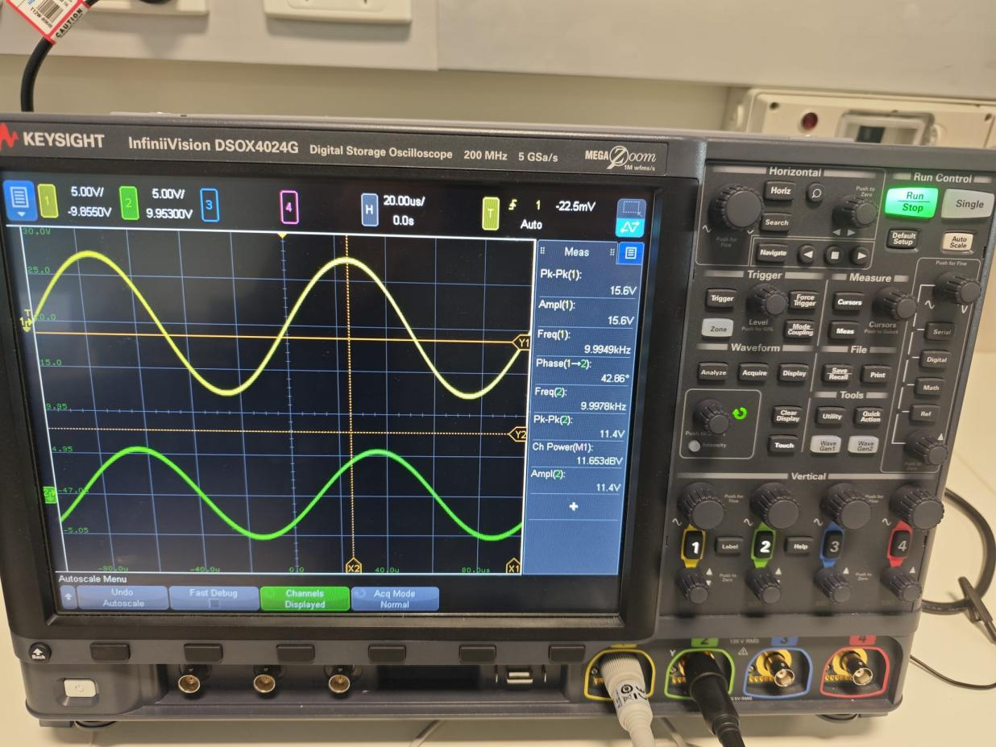
Fig9. Measured value for f=10kHz
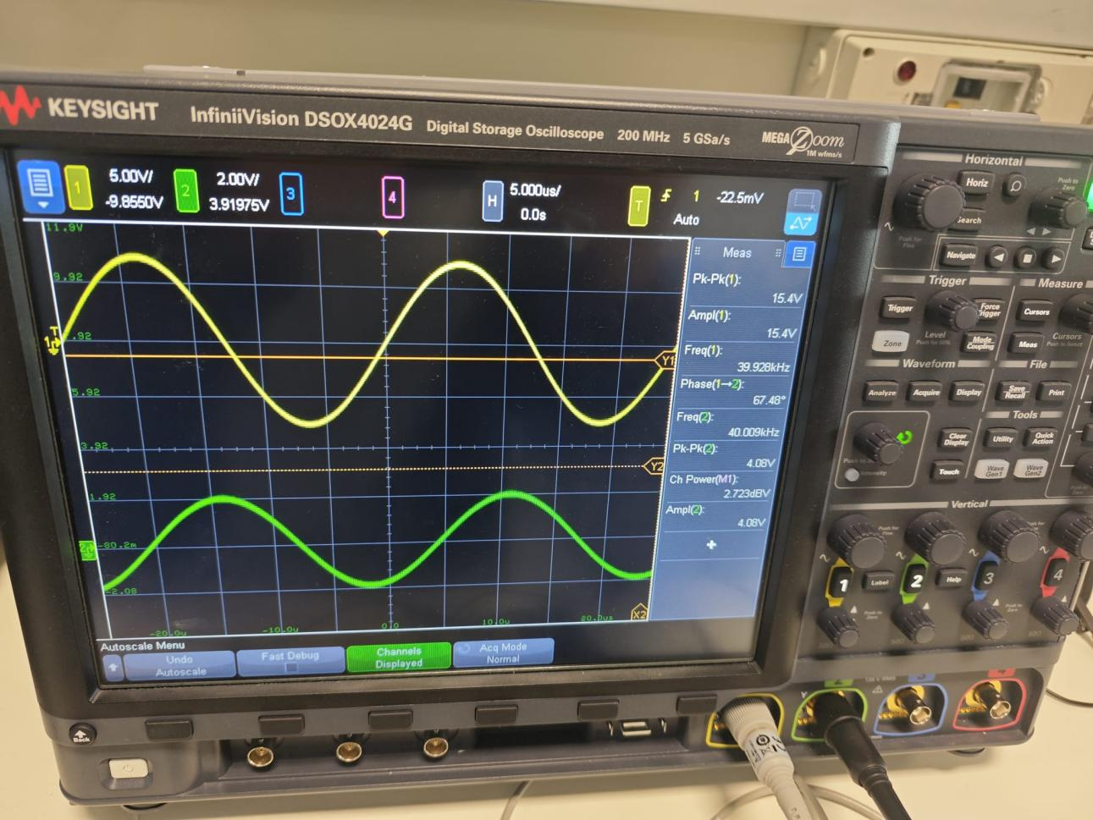
Fig10. Measured value for f=40kHz
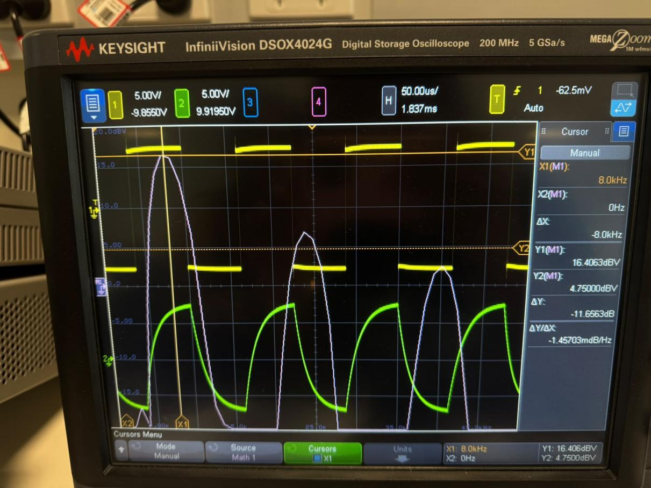
Fig11. Measured value for f=8kHz
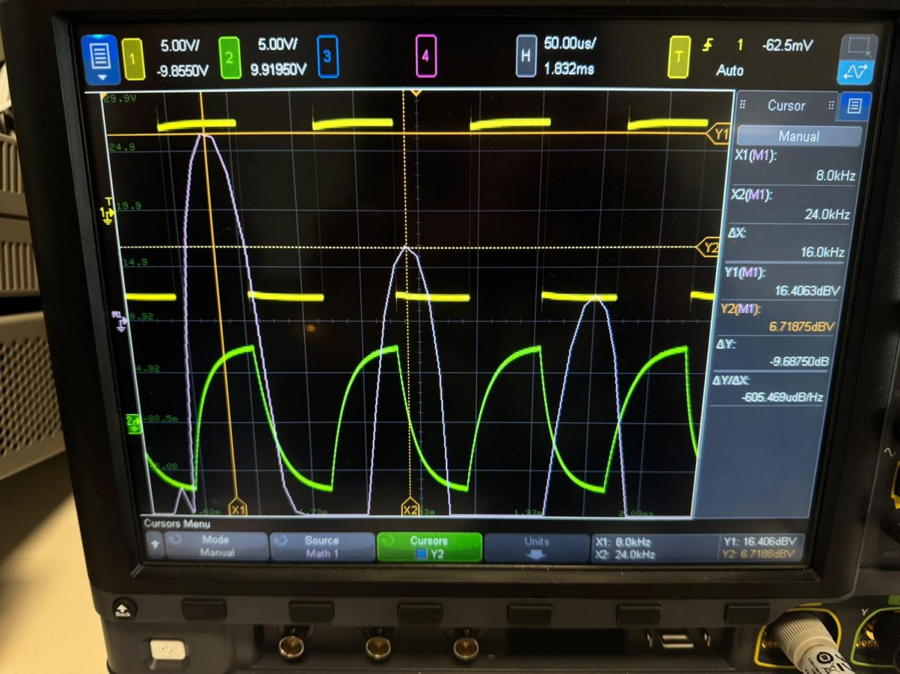
Fig12. Measured value for f=24kHz
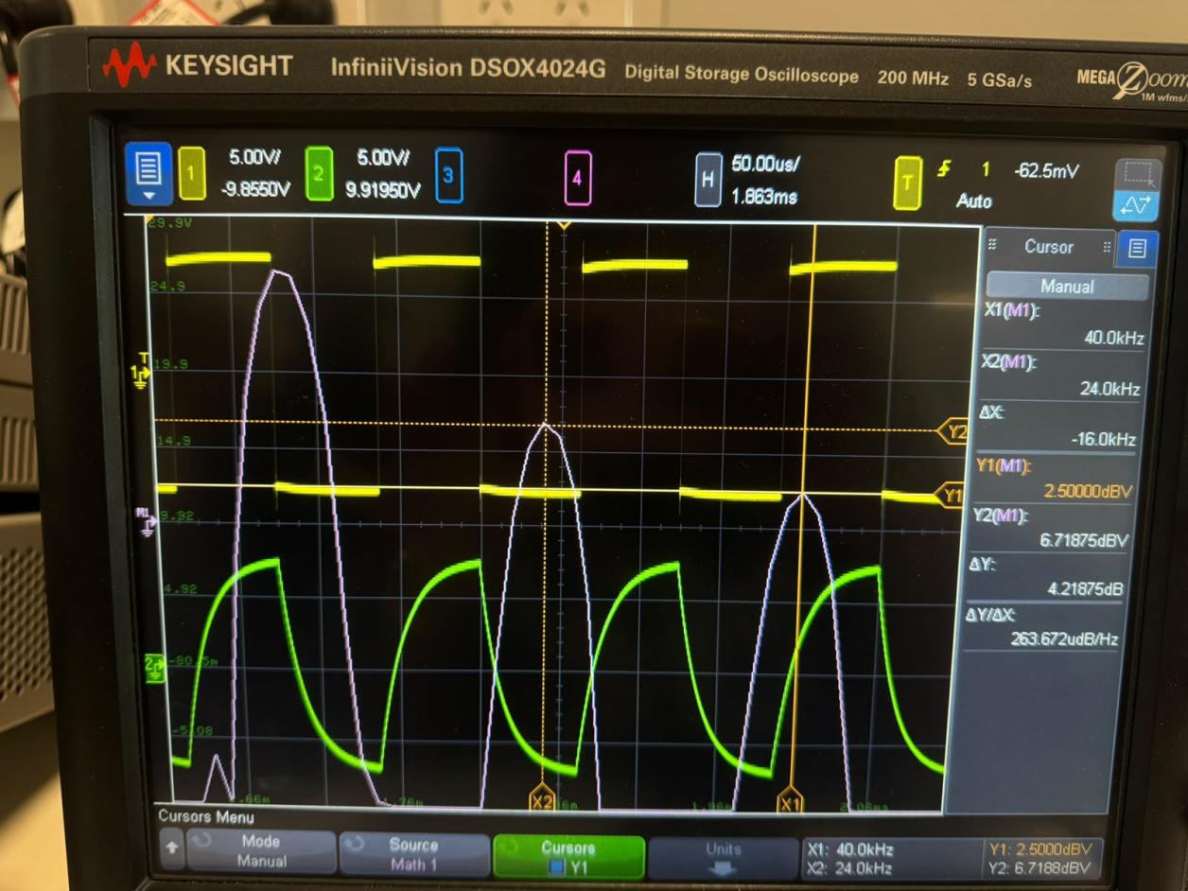
Fig13. Measured value for f=40kHz

